Project Design Phase-II
Technology Stack (Architecture & Stack)

Date | 25 September 2026
Team ID | SWTID-2026-9989
Project Name | Script-Controlled ACL – Restrict Record Access Based on Field Value
Maximum Marks | 4 Marks

Technical Architecture:
The Deliverable shall include the architectural diagram as below and the information as per the table1 & table 2
Architecture: Script-Controlled ACL on the ServiceNow platform
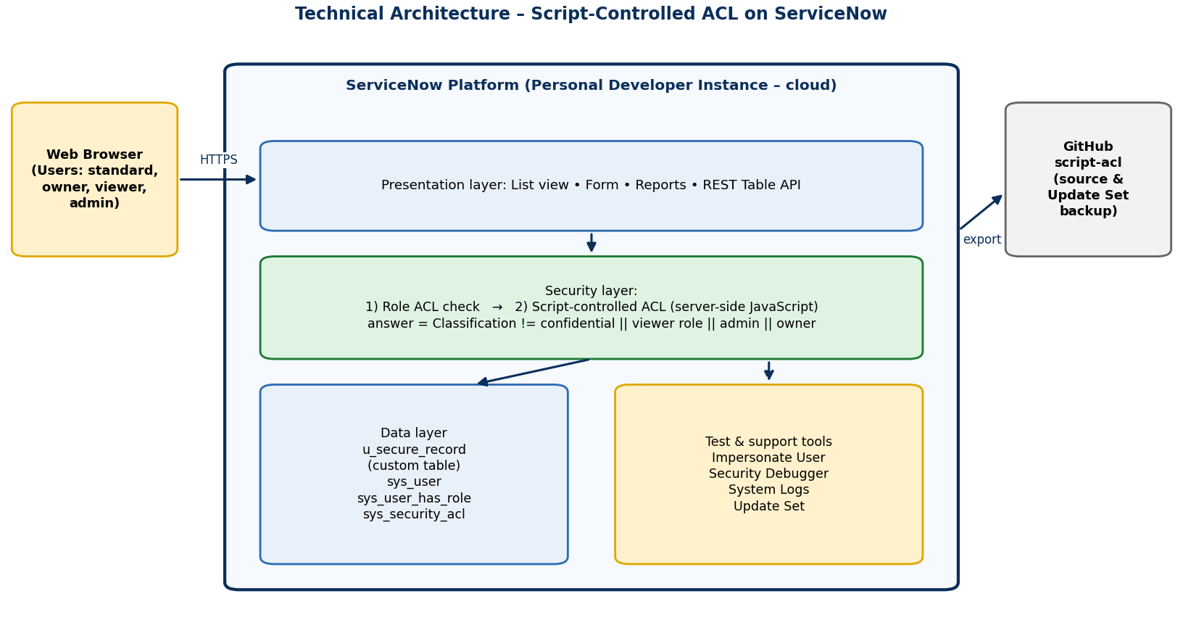
Table-1 : Components & Technologies:
S.No | Component | Description | Technology
- 1. | User Interface | Browser-based ServiceNow list and form views used by all four user types | ServiceNow Platform UI (Next Experience / Classic)
- 2. | Application Logic-1 | Script-controlled read / write ACL that checks the Classification field, role and owner | Server-side JavaScript (ACL script, gs.hasRole, gs.getUserID)
- 3. | Application Logic-2 | Role and user management for viewer, owner and standard users | sys_user_role, sys_user, sys_user_has_role
- 4. | Application Logic-3 | Delete restriction and troubleshooting of access decisions | Delete ACL, Security Debugger, Impersonate User
- 5. | Database | Custom table u_secure_record (Title, Description, Owner, Classification) | ServiceNow platform relational database
- 6. | Cloud Database | Instance database hosted and managed by ServiceNow | ServiceNow Personal Developer Instance (PDI)
- 7. | File Storage | Update Set export and script files kept in source control | Update Set (XML), GitHub repository script-acl
- 8. | External API-1 | Not required – solution is platform-native | N/A (REST Table API used only for testing)
- 9. | External API-2 | Not required | N/A
- 10. | Machine Learning Model | Not applicable – rule-based access control | N/A
- 11. | Infrastructure (Server / Cloud) | Application deployed on a ServiceNow cloud instance; accessed through a web browser | ServiceNow PDI (cloud)

Table-2: Application Characteristics:
S.No | Characteristics | Description | Technology
- 1. | Open-Source Frameworks | No open-source runtime framework; low-code platform features used. Git used for version control. | ServiceNow platform, Git / GitHub
- 2. | Security Implementations | Role-based ACL plus script-controlled record-level ACL; default deny; delete limited to admin; security_admin needed to change ACLs; Security Debugger for verification. | ServiceNow ACLs, roles, elevated privilege
- 3. | Scalable Architecture | Same ACL pattern can be reused on other tables; more classification levels, roles or groups can be added without redesign. | ServiceNow platform (multi-tier, cloud)
- 4. | Availability | Runs on the ServiceNow cloud platform and inherits its availability; no extra servers to maintain. | ServiceNow cloud
- 5. | Performance | ACL script uses only current-record fields and session data – no extra queries – so list views stay within the 3-second target. | Lightweight ACL script

References:
https://c4model.com/
https://developer.servicenow.com/

